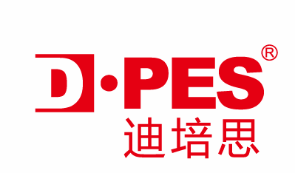
Hotel Reservation Confirmation
公司名称  Company Name | 广州市轩华展览有限公司Guangzhou Xuanhua Exhibitian Ltd |  |  |  | 发件人Addressor |  | Ms Regina
公司邮箱E-mail | service@dpes.com.cn |  |  |  | 公司电话Tel |  | 86-2089089736
客户填写订房资料 Customer Details 截止日期Deadline: 1/30/2015

Registration number
Company Name
Company Address
客户数量Number of Guest
客户姓名Customer Name
(Specify the gender Mr./Ms/ Mrs.)
护照号码Passport No.
Mobile Phone
E-mail Address
预定日期Reservation Date
入住日期Check in Date
退房日期Check out Date
备注Remarks
酒店回复确认（酒店填写）Hotel Conformation(By Hotel)
酒店联系人Contact |  |  |  | 电话Tel
酒店签章Hotel Signature

注：客户必须凭此登记表及护照原件入住酒店。
Condition Policy:
- All clients have to hold this form and original passport for checking in.
- In this free hotel program, D·PES only offer free hotel accommodation (twin bed room) for choosing three nights during the exhibition period (from March 5 to 9). Without this period, you need to responsible for your accommodation to stay.
- If you are only one person to apply this free hotel program, we may arrange you to stay with other person at a twin bed room.
- This form should be filled out completely; you can get the registration number from here.

